Pozdravljene pevke.

Za začetek si poglejte kratek video, ki s(m)o ga pripravili učitelji glasbe.
https://www.youtube.com/watch?v=5mhiUSpLTbc#action=share

Slišali ste, da nas glasba zdravi in povezuje. V teh časih je to še toliko bolj pomembno. Zato skušajmo z glasbo nasmejati, obarvati dneve, navduševati …preko poslušanja, izvajanja in ustvarjanja.

Trenutno je pravi čas, da se naučimo pesem, ki nosi pomembno in zelo lepo sporočilo, da je potrebno stopiti skupaj ne glede na vse in premagati »v našem primeru« ta korona virus. S pomočjo te pesmi so zbrali ogromno finančnih sredstev za humanitarno pomoč ljudem.

https://www.youtube.com/watch?v=M9BNoNFKCBI - Original verzija (lakota v Afriki - 1985 - še danes umre približno 9 milijonov ljudi, predvsem otrok, zaradi lakote!)

https://www.youtube.com/watch?v=Glny4jSciVI - Novejša verzija (potres na Haitiju - 2010 -230.000 žrtev)

Mislim, da se pripravlja tudi 3. verzija pesmi (korona virus - 2020)

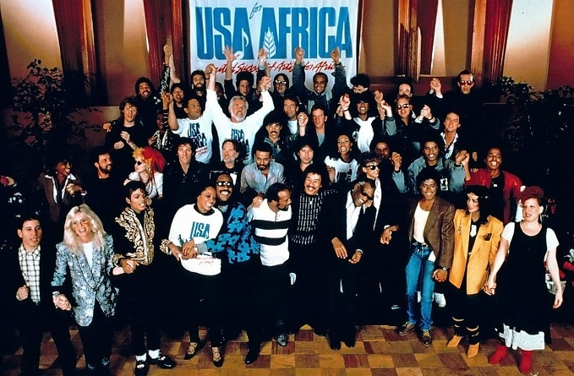

We are the world

There comes a time
When we heed a certain call
When the world must come together as one
There are people dying
Oh, and it's time to lend a hand to life
The greatest gift of all
We can't go on
Pretending day-by-day
That someone, somewhere soon make a change
We're all a part of God's great big family
And the truth, you know, love is all we need
We are the world
We are the children
We are the ones who make a brighter day, so let's start giving
There's a choice we're making
We're saving our own lives
It's true we'll make a better day, just you and me
Oh, send them your heart
So they know that someone cares
And their lives will be stronger and free
As God has shown us by turning stones to bread
And so we all must lend a helping hand

We are the world
We are the children
We are the ones who make a brighter day, so let's start giving
Oh, there's a choice we're making
We're saving our own lives
It's true we'll make a better day, just you and me
When you're down and out, there seems no hope at all
But if you just believe there's no way we can fall
Well, well, well, well let us realize
Oh, that a change can only come
When we stand together as one, yeah, yeah, yeah
We are the world
We are the children
We are the ones who make a brighter day, so let's start giving
There's a choice we're making
We're saving our own lives
It's true we'll make a better day, just you and me
We are the world
We are …
